

Draw it or Lose it

CS 230 Project Software Design Template
Version 1.0

Table of Contents

CS 230 Project Software Design Template 1
Table of Contents 2
Document Revision History 2
Executive Summary 3
Requirements 3
Design Constraints 3
System Architecture View 3
Domain Model 3
Evaluation 4
Recommendations 5

Document Revision History

Version | Date | Author | Comments
1.0 | 03/24/24 | Cory Carter | software requirements for multiple platforms.
1.0 | 04/24/24 | Cory Carter | Recommendations updated.

Executive Summary

The Gaming Room aims to extend the reach of its popular Android game, "Draw It or Lose It," by transforming it into a web-based application accessible on different platforms. This strategic move intends to broaden the game's player base and make it more inclusive, enabling teams to participate in puzzle-solving challenges based on a collection of pre-made drawings.
To address this objective, Creative Technology Solutions (CTS) suggests creating an adaptable web version of the game. This solution will utilize contemporary web technologies to ensure seamless compatibility across various devices and operating systems. Emphasis will be placed on enhancing user interaction through an intuitive interface, guaranteeing the originality of game and team identifiers, and implementing efficient resource management by maintaining a single instance of the game in memory. We’re committed to assisting them in developing an updated web-compatible edition of the game. This entails ensuring that the game remains enjoyable and user-friendly across various devices such as phones, computers, and tablets. Our goal is to ensure fairness and synchronicity among players by ensuring that everyone sees the same drawing simultaneously during gameplay with friends. Moreover, we'll streamline the process of team identification, safeguarding each team's exclusive name from being claimed by others.

Requirements

- A game will have the ability to have one or more teams involved.
- Each team will have multiple players assigned to it.
- Game and team names must be unique to allow users to check whether a name is in use when choosing a team name.
- Only one instance of the game can exist in memory at any given time. This can be accomplished by creating unique identifiers for each instance of a game, team, or player.

Design Constraints

1. Multiplayer Online Experience: Ensuring seamless real-time interaction when individuals play together on the web, even if they are geographically distant, is imperative.
2. Universal Compatibility: The game must function effectively across various devices, from aging laptops to state-of-the-art tablets, necessitating optimization for both large and small screens.
3. Preserving Originality: Protecting the uniqueness of team names requires implementing a sophisticated system to verify name availability and prevent duplicates.

Implications for Development:
1. Efficient Internet Utilization: It's crucial to leverage internet resources intelligently to facilitate synchronous gameplay without any waiting periods.
2. Universal Design: The game must be crafted to deliver an enjoyable and intuitive experience on any device it's accessed from.
3. Rapid Name Verification: Implementing a swift mechanism to verify the availability of team names during selection is essential.

The project encounters various hurdles, such as guaranteeing instantaneous interaction within a web environment, ensuring compatibility across diverse devices, and maintaining the originality of both game and team names. These limitations direct the development trajectory, highlighting the importance of effective server communication, adaptable design, and distinct identifiers for games, teams, and participants.

The way the application is spread out brings up worries about security. We need to do things to keep user data safe, stop people who aren't allowed from getting in, and make sure the client and server can talk securely. This means we should scramble important info, have strong ways to check who's logging in, and make sure the input is checked well.

System Architecture View

Please note: There is nothing required here for these projects, but this section serves as a reminder that describing the system and subsystem architecture present in the application, including physical components or tiers, may be required for other projects. A logical topology of the communication and storage aspects is also necessary to understand the overall architecture and should be provided.

Domain Model

How the Game Is Structured:

Base Component (Entity): Consider this as the fundamental element of the game. Everything within the game, such as players, teams, and the game itself, originates from this foundational component, which comprises a distinct identifier and name for each entity.

Game Component: This encompasses the entire game setup, encompassing all necessary elements for gameplay, such as participating teams.

Team Component: Every team within the game consists of individual players. This aspect oversees the team's identity and its member roster.

Player Component: This pertains to each individual engaged in the game, encompassing their identity and team affiliation.

We employ object-oriented principles to outline the game's framework. The model consists of the following classes:
Entity: Serving as a base class for shared attributes such as id and name.
Game: Extends from Entity and houses multiple teams.
Team: Similarly extends from Entity and encompasses multiple players.
Player: Also extends from Entity, representing individual participants. This design leverages inheritance to minimize repetition and encapsulation to proficiently handle game state.
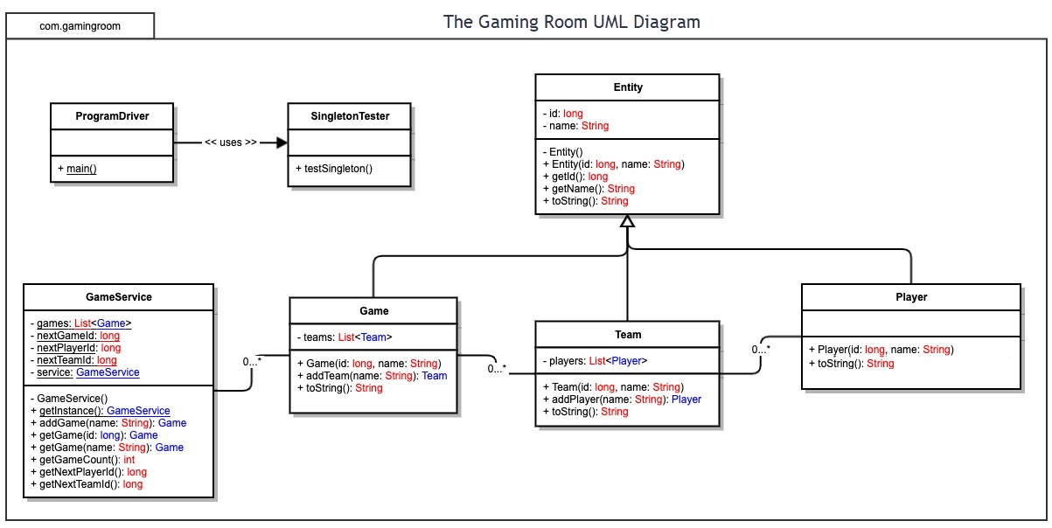

Evaluation

Development Requirements | Mac | Linux | Windows | Mobile Devices
Server Side | Adaptable command-line instructions for configuring server settings, accessing, or effecting modifications.  Characteristics: Widely used in web hosting.  Benefits: Upgradable, offering diverse options to meet various web hosting needs.  Drawbacks: Less favored for web hosting services. | Characteristics: Secure, highly favored.  Benefits: Security vulnerabilities are identified and addressed early, making it the top choice for web hosting services.  Drawbacks: Challenges in finding applications that meet specific web hosting requirements | Compared to other operating systems, this one offers a wider selection of software.  Characteristics: It holds dominance over other platforms and is known for being a closed platform.  Benefits: Requires high resources, boasts faster loading times, and offers high comfort levels.  Drawbacks: Prone to easy virus attacks and lacks adequate technical support | Having a stationary server that can be centrally tracked is preferable, while other devices may offer better specifications.  Characteristics: It enjoys greater popularity and boasts high portability.  Benefits: Offers wider accessibility, improved compatibility, and cost-effectiveness.  Drawbacks: Limited compatibility with various smart mobile devices and security vulnerabilities.
Client Side | Moderate skills and time investment needed. Costs are comparable to Windows. | Extensive skills and time commitment necessary. Minimal expenses involved. | Basic proficiency and time commitment needed. Comparable expenses to Mac. | Allows clients and developers to access updates from any location. Requires slightly more effort to implement compared to other devices.
Development Tools | When using Macs, Swift is a popular language choice, often complemented by useful tools like Notepad++. However, Macs support a wide range of languages, including HTML, CSS, and JavaScript, along with libraries for frontend development. Additionally, they accommodate general-purpose languages such as Java, Python, PHP, and Ruby. | Linux is compatible with a variety of development tools like Visual Studio, Eclipse, and Notepad++, offering a user-friendly experience. Additionally, Linux supports numerous programming languages and tools, including HTML, CSS, and JavaScript for frontend development, as well as general-purpose languages like Java, Python, PHP, and Ruby, among others. | Easier to use than Linux, Windows offers compatibility with the same set of languages and tools. Popular development environments like Visual Studio and Eclipse are available, alongside simpler tools like Notepad++. Supported languages include HTML, CSS, and JavaScript for frontend development, as well as general-purpose languages such as Java, Python, PHP, and Ruby, among others. | You can develop numerous applications utilizing Android and Swift. Both languages and software are compatible across all platforms. The languages encompass a wide range, including HTML/CSS/JavaScript, alongside supporting libraries for frontend development and general-purpose languages such as Java, Python, PHP, and Ruby.

Recommendations

- Operating Platform: I suggest initiating the development of the web-based game on Windows devices. Windows provides a sturdy platform with an extensive array of available software tools. This choice also reduces the learning curve and initial expenses for development. Additionally, Windows supports various Integrated Development Environments (IDEs), offering flexibility and options for developers.

- Operating Systems Architectures: Windows provides an extensive range of services tailored for GUI-based applications, crucial for tasks like rendering graphics, managing multimedia, handling messaging, and interacting with web services. These services are accessible through user accounts or dedicated servers, granting flexibility in system architecture.

- Storage Management: Storage Spaces allows users to pool physical disk drives together into storage pools and create virtual drives called storage spaces. These storage spaces can then be formatted with a file system and used like any other drive on the system. This feature offers flexibility and redundancy options, such as mirroring or parity, to protect data against drive failures. It's particularly useful for creating large, fault-tolerant storage volumes that can be used for various purposes, including data storage, media libraries, or backups.

- Memory Management: For housing a database or library of images for the game, Windows offers memory allocation features allowing storage of pictures outside the default picture folder. This capability enhances the organization and security of project files, especially beneficial when operating within an Integrated Development Environment (IDE) and accessing files for game development.

- Distributed Systems and Networks: Given the aim of catering to multiple platforms such as web, iOS, and Android, opting for a cross-platform game development strategy is prudent. Tools like "Develop 4" facilitate cross-platform game creation and are compatible with various devices. Exporting the game to diverse platforms streamlines cross-play. Nevertheless, it's crucial to establish a robust server infrastructure capable of accommodating large player volumes and implementing backup power solutions to mitigate outages or connectivity disruptions.

- Security: Although Windows comes equipped with built-in security protection software, it's prudent to implement additional measures to effectively secure user data and information. Employing supplementary security solutions can enhance data protection. Nevertheless, Windows does provide real-time scanning for malware, viruses, and security threats, ensuring proactive security updates to safeguard both the system and user information.

Based on the requirements and constraints outlined, along with the evaluation of different operating platforms and development tools, here are the recommendations for The Gaming Room's web-based game "Draw It or Lose It":

1. **Operating Platform:** The development of the web-based game should be initiated on **Windows** devices. Windows provides a robust platform with a wide array of available software tools, reducing the learning curve and initial expenses for development.

2. **Operating Systems Architectures:** Windows offers an extensive range of services tailored for GUI-based applications, which are crucial for tasks like rendering graphics, managing multimedia, and interacting with web services. These services are accessible through user accounts or dedicated servers, granting flexibility in system architecture.

3. **Storage Management:** Utilize **Storage Spaces** on Windows, allowing users to pool physical disk drives together into storage pools and create virtual drives called storage spaces. This feature offers flexibility and redundancy options to protect data against drive failures, suitable for various purposes, including data storage, media libraries, or backups.

4. **Memory Management:** Leverage Windows' memory allocation features for housing a database or library of images for the game. This enhances the organization and security of project files, especially beneficial when accessing files within an Integrated Development Environment (IDE) for game development.

5. **Distributed Systems and Networks:** Opt for a cross-platform game development strategy to cater to multiple platforms such as web, iOS, and Android. Tools like "Develop 4" facilitate cross-platform game creation and streamline cross-play. Ensure robust server infrastructure capable of accommodating large player volumes and implementing backup power solutions to mitigate outages or connectivity disruptions.

6. **Security:** Implement additional security measures to effectively secure user data and information, despite Windows' built-in security protection software. Employ supplementary security solutions to enhance data protection, ensuring proactive security updates to safeguard both the system and user information.

These recommendations align with the development requirements and constraints, ensuring efficient development, seamless gameplay experience, and enhanced security measures for "Draw It or Lose It" as it transitions into a web-based application accessible across various platforms.

